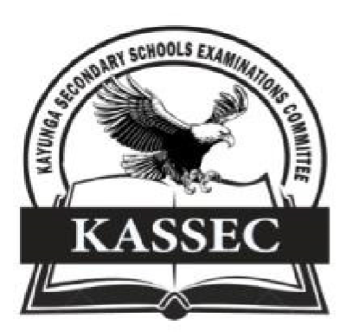

**241/1**

**History & Political Education**

**Paper 1**

**July /August 2024**

**2 : 15 Minutes**

**KAYUNGA SECONDARY SCHOOLS EXAMINATIONS COMMITTEE (KASSEC)**

**JOINT MOCK EXAMINATION 2024**

**Uganda Certificate of Education**

**HISTORY AND POLITICAL EDUCATION.**

**Paper 1**

**2 hours 15 minutes**

**INSTRUCTIONS TO CANDIDATES:**

* This paper consists of sections **A** and **B.** It has four examination items.
* Section **A** is compulsory.
* Answer **one** item from Section **B.**
* Answer **three** examination items in all.
* Any additional item answered will not be scored.
* All answers must be written in the answer booklet(s) provided.

**Turn Over**

**SECTION A:** **Answer all items in this section**.

1. In many parts of east Africa, the arrival of Islam and Christianity brought significant social and cultural changes. Some people think these changes are good, while others think they are bad. The central government through the local and religious leaders have embarked on educating people about these religions. You have been identified to make a presentation that explains how these religions have affected your community.

**Task**

Write a presentation addressing the above issue in the scenario.

2. In Kazoba District, a group of immigrants settled in the area and took up the leadership of the district. They subjected the natives to unjust treatment which led them to untold suffering. The natives would like to regain their independence as it is the only way this unfairness can be solved. You have been identified to educate these natives.

**Task:**

(a) In an essay, explain ways how they can restore their status.

**SECTION B (attempt only one question from this area)**

3. During the previous local council elections in Uganda, it was reported that the voter turn up was significantly low. This was attributed to the fact that a number of people did not value local government systems and felt they were not important. As a result, the ministry of local government embarked on sensitizing the people about them

**Task.**

Educate people in different parts of the country about the above**.**

4. The economic integrations like East Africa community, the ECOWAS, IGAD among others have been formed to solve post-independence, political and economic problems in the different regions. Recently the president of Uganda Yoweri Museveni met with many leaders of Non-aligned movement at munyonyo international conference hall. Many things were discussed, but members of opposition in Uganda’s parliament dismissed this conference as a wastage of resources and time because they don’t see any immediate benefit for Uganda.

**Task**

Write an essay to educate the opposition members of parliament on the above.

**END**